**Jargon Busting in Artificial Intelligence and Machine Learning**

With reference from session by Prof. Mitesh Khapra and Pratyush kumar

With the advancement in computer science you might have come across various terms such as Artificial Intelligence, Machine learning, Deep Learning, Data science among others. There is a lot of confusion in understanding the same.

Some of the terms that are floating around are specified in the below image:

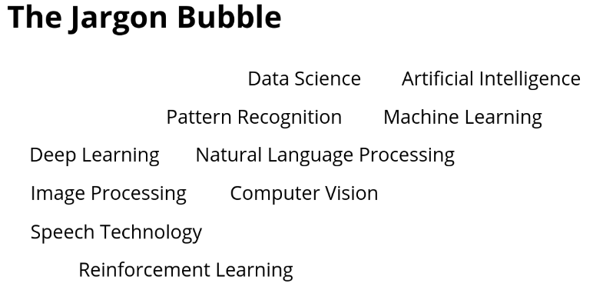

Image credit: One Fourth Labs

Now there is the ‘Robert Bosch centre for Data Science and Artificial Intelligence’

Why is it Data science and Artificial Intelligence instead of a single term?

The question arises is are they the same? or are they different? If yes how are they different?

If you look for definitions to clear that jargon you will find some of these definitions:

**Artificial intelligence (AI)**, sometimes called machine intelligence, is intelligence demonstrated by machines, in contrast to the natural intelligence displayed by humans and other animals.

**Machine learning** is a field of computer science that uses statistical techniques to give computer systems the ability to “learn” with data, and without being explicitly programmed.

The above definition says Machine Learning involves statistical techniques, but what about Artificial Intelligence? Does it not involve statistical techniques? It may be confusing. It does creates certain questions.

To clear the confusion lets look at it in an unorthodox approach:

**Artificial Intelligence**

AI can be understood as a collection of tasks, abilities and methods

The following maps human abilities to those of Artificial Intelligence-

**Abilities include**- To see things(i.e computer vision), listen to sounds(i.e Speech Recognition), read and write(i.e Natural Language Processing), make decisions(i.e Planning/Decision Making)

**Tasks include**- To classify images, to recognize and differentiate speech and sound, to generate and classify documents, to make decision based on different abilities.

**Methods include**-

Expert Systems: To explicitly program system to complete tasks. Here it follows only predetermined algorithms.

Machine Learning: Involves algorithms with graphical models. It learns on its own without need for explicit programming based on input, output and parameters.

Deep Learning: It is a family of machine learning. Complex algorithms that are better than other algorithms of machine learning. It involves learning from huge amounts of data.

Reinforcement Learning: It involves planning and making complex decisions based on deep learning.

AI encompasses all of these:

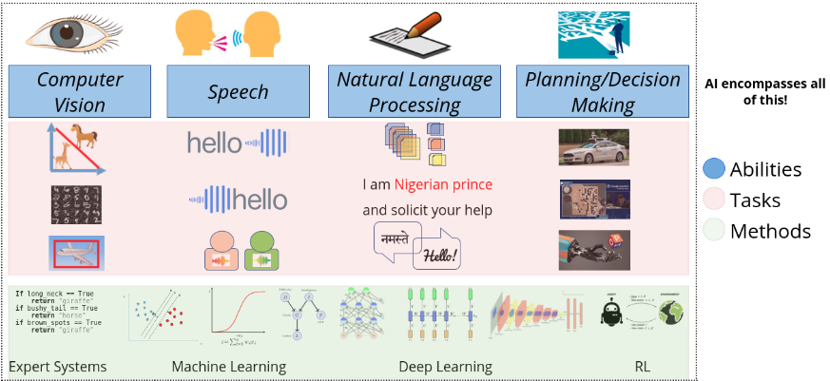

Image credit: One Fourth Labs

**Pattern Recognition**

“The field of patter recognition is concerned with the automatic discovery of regularities in data through the use of computer algorithms and with the use of these regularities to take actions such as classifying the data into different categories.” - Christopher Bishop

Most of the Artificial Intelligence involve pattern recognition.

There is need of pattern recognition before classifying image in computer vision, recognizing speech in speech recognition, to classify documents in NLP or making a decision in reinforcement learning.

**Image Processing**

Is image processing different from computer vision?

In an example of dark image of a car in night, we cannot see the make of the car but however we can convert the image to day image. We can further work on that reprocessed image with computer vision. This is how Image Processing and Computer Vision go hand in hand but are different.

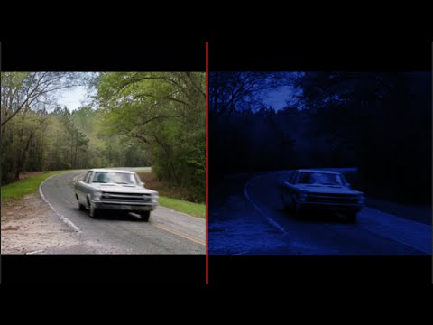

Image credits: Photo Bots

**Data Science**

Is it a subset of AI, a super set or neither?

Data science is the systematic study of data through observation and experiments to visualize data.

Is that all?

Data science may also involve predictive analysis which makes use of NLP to make predictions by leveraging its capabilities. NLP is one of the methods. It may make use of multiple such methods for predictions.

So that breaks down the complexity to gain a better insight in the field of Artificial Intelligence and Machine Learning among others.

**References:**

Jargon busting by One Fourth Labs- <https://www.youtube.com/watch?time_continue=2752&v=OMGt-jcMlCs>

Pattern Recognition and Machine Learning by Christopher Bishop